1. Download and Install Psychopy
   1. Go to [www.psychopy.org](http://www.psychopy.org)
   2. Download link at the right 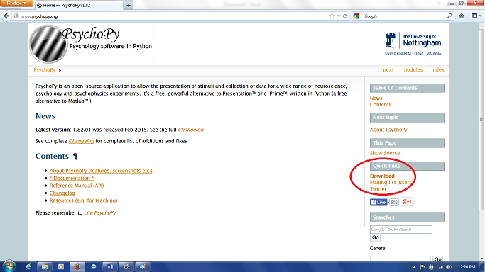
   3. Preferably get STANDALONE version v1.82.01 (needs to be the standalone version)
   4. If newer versions have come out, you should be able to find a place to get older versions on that page
   5. If you have to get a newer version and the task doesn’t work, contact Andrew Poppe ([poppe076@gmail.com](mailto:poppe076@gmail.com)) to get the task working again
   6. Once you download it, run the .exe to install psychopy
   7. Take note of where it is installing (you’ll use this info later) -- most likely it will be in C:\Program Files (x86)\PsychoPy2
2. Download the task files – might need to contact Andrew Poppe for these
   1. At minimum, you need “source_monitoring.py” and "wordlist.csv"
   2. Store them in a folder somewhere that is handy
   3. Note that “wordlist.csv” and “source_monitoring.py” have to be in the SAME directory otherwise the task won’t run.
3. Change default application for opening “source_monitoring.py”
   1. Navigate to the folder you saved that file
   2. Right click it and click “Properties”
   3. In the box that pops up, click “Change” next to the line that says “Opens with”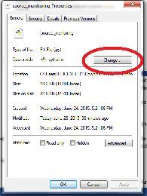
   4. Click “Browse”
   5. Navigate to the folder where you installed PsychoPy -- most likely C:\Program Files (x86)\PsychoPy2
   6. In that folder, double click “pythonw” (not “python”)
   7. Click OK
   8. Click OK
4. Create shortcut to task
   1. In the folder where you saved the task files, right click on “source_monitoring.py”
   2. Click “create shortcut”
   3. Move that shortcut to wherever you want to run the task from (the desktop, for instance)
   4. From now on, you should be able to double-click that file to run the task (after you follow the rest of these instructions)
5. Download ASIO4ALL audio driver
   1. Go to <http://www.asio4all.com/>
   2. Click on the link with “English” next to it
   3. Save the file
   4. Open the .exe that downloads
   5. During installation, make sure to check “Rewuschel” and “Off-Line Settings” 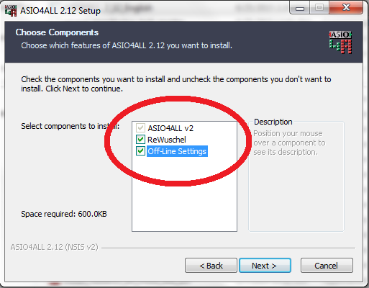
   6. Finish installation
   7. There should now be a folder called “ASIO4ALL v2” in the Start Menu “All Programs” section 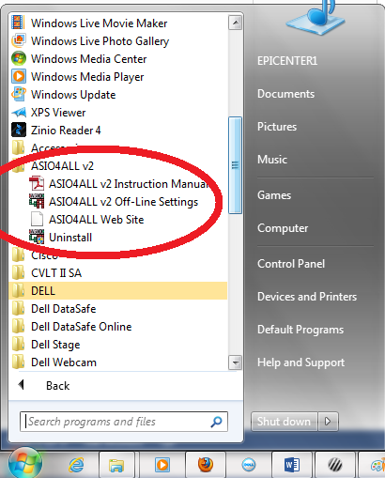
6. Plug in your USB headphones
   1. Make sure the device drivers install completely
7. Open “ASIO4ALL v2 Off-Line Settings”
   1. Open Start Menu
   2. Click “All Programs”
   3. Click on “ASIO4ALL v2” folder
   4. Double click on “ASIO4ALL v2 Off-Line Settings”
   5. When it opens, click the wrench in the bottom right.
   6. Next, you want to find your USB headphones in the WDM device list on the left side (mine says “USB Audio Device”)
   7. Make sure that device is on and all other devices are off, like this: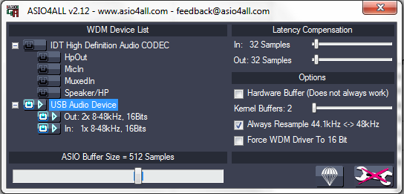 You can click on those little buttons to turn them on/off.
8. You should now be ready to run the task!
   1. To run, just double-click the shortcut to “source_monitoring.py” you created.